Mubashir abbas

  Digital Empower network

Task no 2

**Web scraping using python:**

**Important libraries:**

1. import pandas as pd
2. import requests
3. from bs4 import BeautifulSoup

**target url :**

url=<https://islamqa.info/en/answers/1/interruption-of-wudu>

**1.m=requests.get(url)**

**2.m.content**

**Result:**

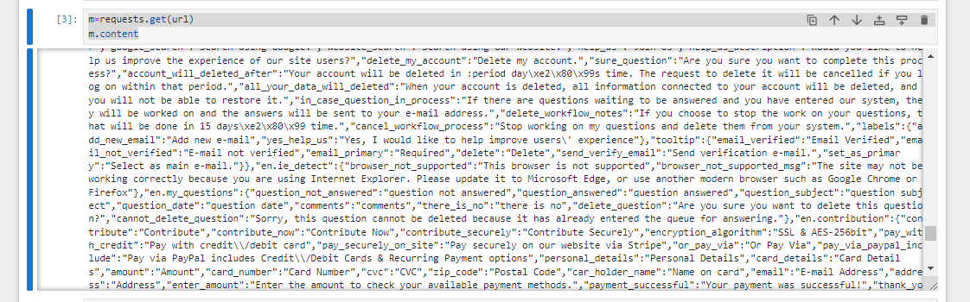

**3 .m2 = BeautifulSoup(m.content, "html.parser")**

**4. m2.findAll(attrs={'class':'content'})**

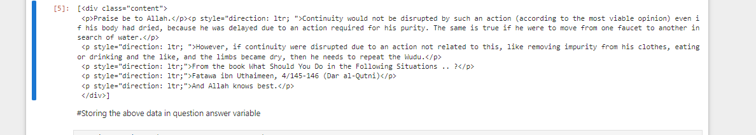

**5 .question=m2.findAll(attrs={'class':'content'})**

**6. question**



**7. question[0].text**



**Commands:**

**8. m3=question[0].text.replace("\n"," ")**

**9. m2.find(attrs={"class":"tittle is -4 is -size-5-touch"})**

**10. m2.find(attrs={"class":"title is-4 is-size-5-touch"}).text.replace("\n"," ")**

**11 summary=m2.find(attrs={"class":"title is-4 is-size-5-touch"}).text.replace("\n"," ")**

**12 m2.find(attrs={"class":"subtitle has-text-weight-bold has-title-case cursor-pointer tooltip"}).text.replace("\n"," ")**

**13. questionno=int(m2.find(attrs={"class":"subtitle has-text-weight-bold has-title-case cursor-pointer tooltip"}).text.replace("\n"," "))**

**14. data=[[url,questionno,summary,question]]**

**15.data**

[16]:

[['<https://islamqa.info/en/answers/1/interruption-of-wudu>',

[<div class="content">

<p>Praise be to Allah.</p><p style="direction: ltr; ">Continuity would not be disrupted by such an action (according to the most viable opinion) even if his body had dried, because he was delayed due to an action required for his purity. The same is true if he were to move from one faucet to another in search of water.</p>

<p style="direction: ltr; ">However, if continuity were disrupted due to an action not related to this, like removing impurity from his clothes, eating or drinking and the like, and the limbs became dry, then he needs to repeat the Wudu.</p>

<p style="direction: ltr;">From the book What Should You Do in the Following Situations .. ?</p>

<p style="direction: ltr;">Fatawa ibn Uthaimeen, 4/145-146 (Dar al-Qutni)</p>

<p style="direction: ltr;">And Allah knows best.</p>

</div>]]]

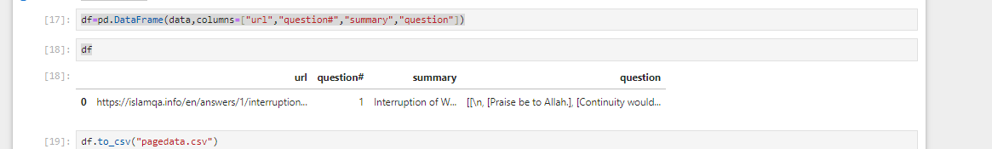

**The Scraped data screenshot is as below:**

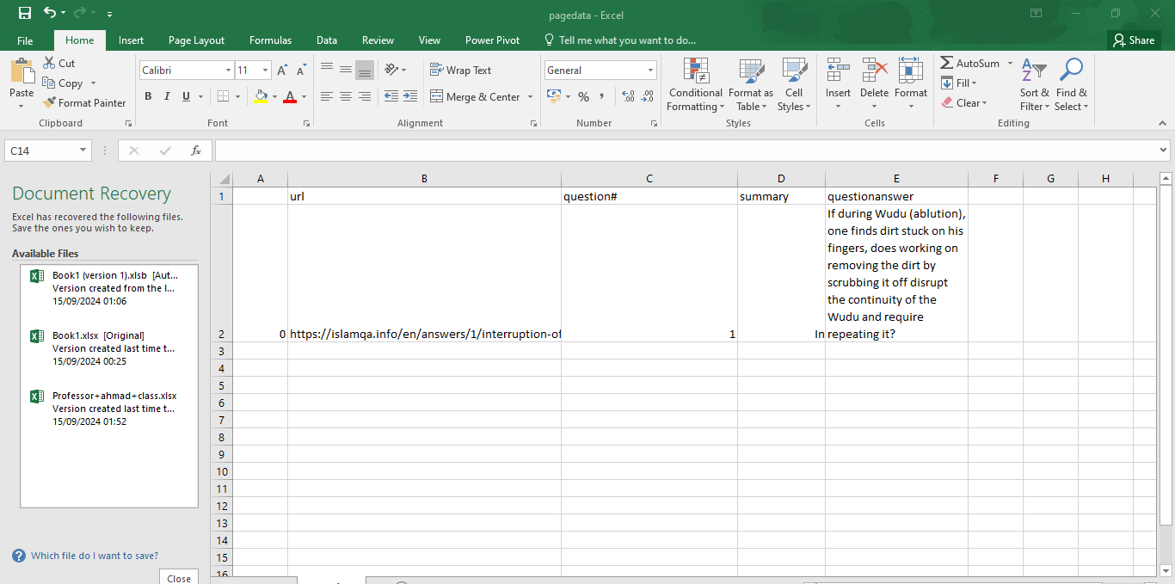

As this way we can scrape data froma website by using python